  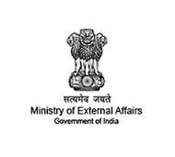 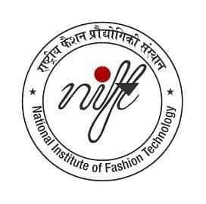

National Institute of Fashion Technology Daman

*Cordially invites you to*

**G20 University Connect**

Lecture Series

Special Guest : Ambassador Bhaskar Balakrishnan

*Former Indian Ambassador & Science Diplomacy Fellow RIS New Delhi*

Venue: NIFT Campus, Block 6,

Govt. Engg. College, Daman

Time : 3 PM, Monday, 24th April, 2023

 